|  |  |  |  |
| --- | --- | --- | --- |
|  |  | |  |
| **Mobile WiFi Product FAQs** | |
| **Mobile WiFi Product FAQs** | |
| **Issue** | **01** |
| **Date** | **2024-08-01** |

­­

Contents

1 Hide or unhide the Wi-Fi name 1

2 Change the password for logging in to the web-based management page 2

3 Obtain the initial password for logging in to the web-based management page 3

4 Query the software version 4

5 Modify and set the APN 5

6 View and change the Wi-Fi name and password 6

7 Restore factory settings 7

8 Wi-Fi is automatically disabled and cannot be detected 8

9 View and manage devices connected to the Wi-Fi 9

10 View and manage data traffic 11

# Hide or unhide the Wi-Fi name

If the Wi-Fi name is hidden, computers, phones, and other wireless devices will not be able to detect the Mobile WiFi's wireless network. To connect to the Wi-Fi network, you will need to manually enter the Wi-Fi name on your device. This helps enhance Wi-Fi security.

Once the Wi-Fi name is hidden, any device that has ever connected to the Mobile WiFi before will automatically connect to the Wi-Fi within the valid range.

Connect your device to the Mobile WiFi.

Enter **192.168.8.1** in the browser's address bar, and enter the login password of the web-based management page.

Go to **Advanced** > **Wi-Fi** > **Wi-Fi Security Settings**, and hide or unhide the Wi-Fi name.

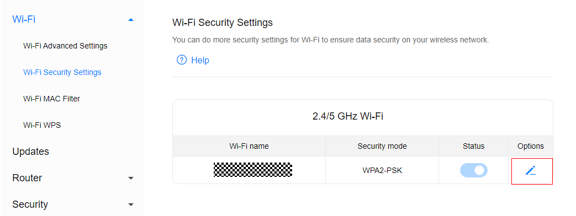

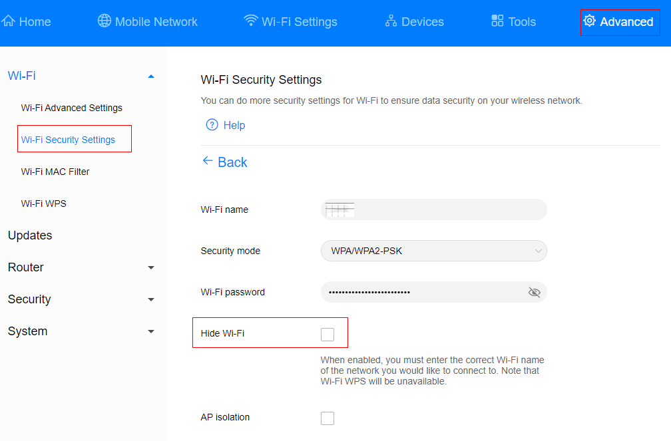

­

# Change the password for logging in to the web-based management page

Connect your device to the Mobile WiFi.

Enter **192.168.8.1** in the browser's address bar, and enter the login password of the web-based management page.

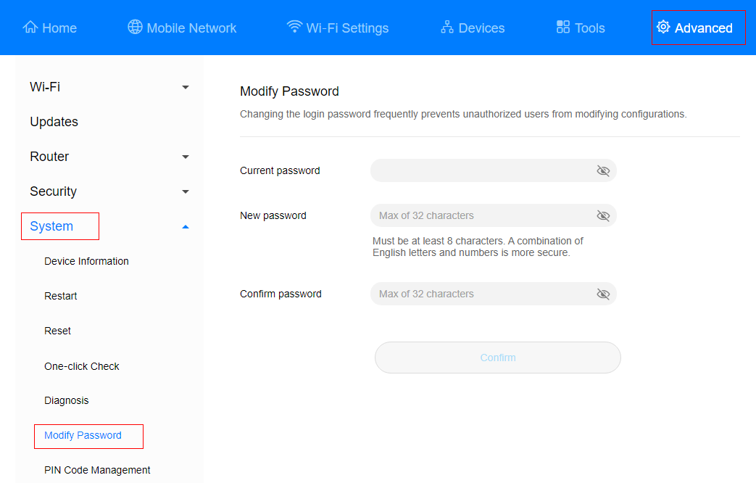Go to **Advanced** > **System** > **Modify Password**, enter the **Current password**, **New password**, and **Confirm password**, and click **Confirm**.

­­

# Obtain the initial password for logging in to the web-based management page

Method 1:

Find the default login password on the label attached to the rear cover of the Mobile WiFi.

Method 2:

Power on the Mobile WiFi and access its home screen.

Swipe up on the home screen and go to **More** > **Device information**, where you'll find the default login password.

­­

# Query the software version

You can check the software version in either of the following ways:

Method 1:

Power on the Mobile WiFi and access its home screen.

Swipe up on the home screen and go to **More** > **Device information**, where you'll find the software version.

Method 2:

Connect your device to the Mobile WiFi.

Enter **192.168.8.1** in the browser's address bar, and enter the login password of the web-based management page.

Go to **Advanced** > **System** > **Device Information**, where you'll find the software version.

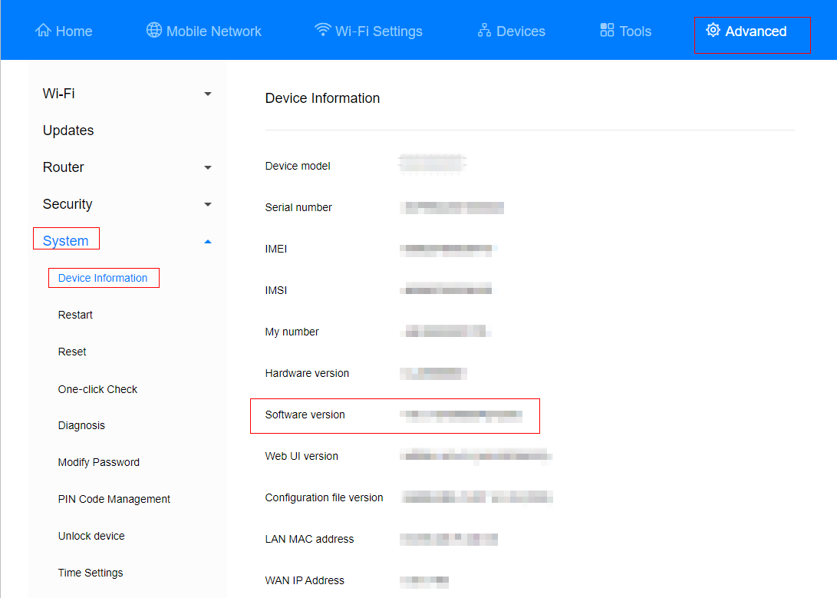

­­

# Modify and set the APN

The APN is a network access technology that determines the mode that the SIM card uses to access the network, and is also a mandatory parameter for Internet access. For example, mobile phone users can access many types of external networks (such as Internet, WAP websites, and internal networks of enterprises). The access scope and access mode vary according to the access point. Therefore, the network side needs to allocate the IP address of the corresponding network segment according to the APN parameter.

Mainstream APNs have been configured on the Mobile WiFi before delivery. If you use a SIM card of a non-mainstream carrier, you may need to manually create an APN, before you can access the Internet. For example, if you use an IoT card, add the APN information that matches the card to access the Internet.

Connect your device to the Mobile WiFi.

Enter **192.168.8.1** in the browser's address bar, and enter the login password of the web-based management page.

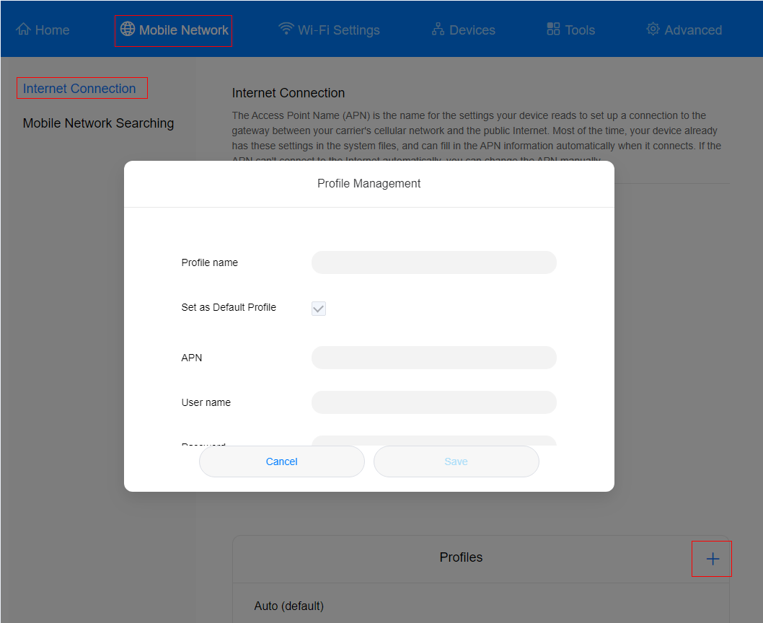Go to **Mobile Network** > **Internet Connection**, click **+** to add an APN, and enter relevant parameters.

­­

# View and change the Wi-Fi name and password

Method 1: Find the default Wi-Fi name and password on the label attached to the rear cover of the Mobile WiFi.

Method 2: On the Mobile WiFi screen

Power on the Mobile WiFi and access its home screen.

Swipe up on the home screen and go to **More** > **Wi-Fi connection**, where you can view the Wi-Fi name and password.

Method 3: On the web-based management page

Connect your device to the Wi-Fi network of the Mobile WiFi.

Enter **192.168.8.1** in the browser's address bar, and enter the login password of the web-based management page.

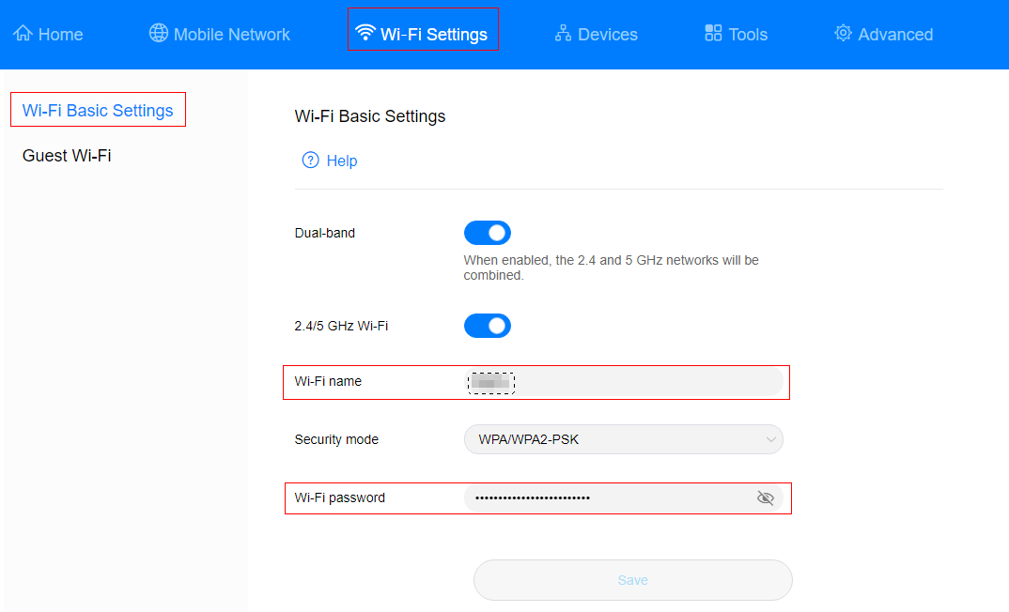Go to **Wi-Fi Settings** > **Wi-Fi Basic Settings** to view or change the Wi-Fi name and password.

­­

# Restore my Mobile WiFi to its factory settings

To restore the Mobile WiFi to its factory settings, use either of the following methods.

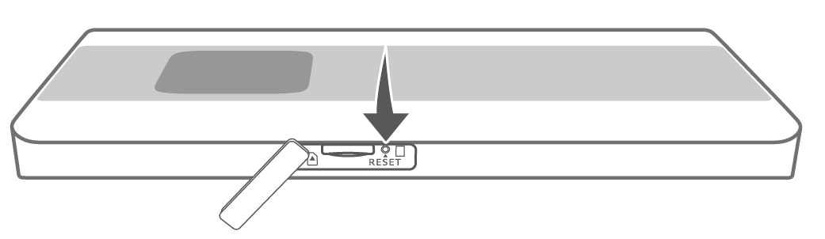Method 1: When the Mobile WiFi is powered on, open the SIM card cover on the side, and use a needle-shaped object to press and hold the RESET button for about 2 seconds.

Method 2: Swipe up on the device home screen to go to **More** > **Settings**, select **Reset**, and touch .

Method 3: Log in to the web-based management page, go to **Advanced** > **System** > **Reset**, and click **Reset**.

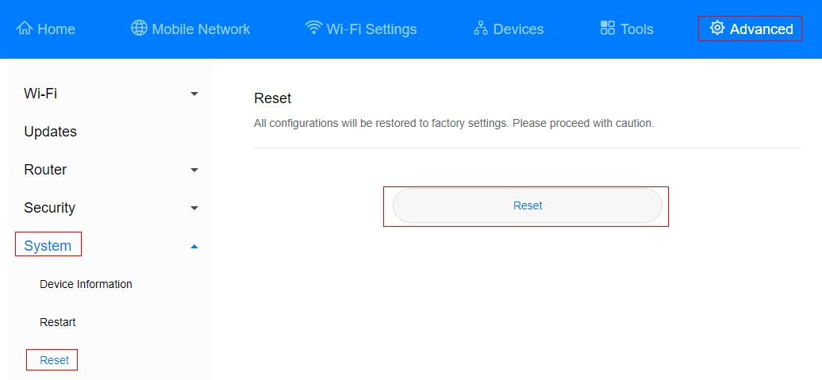

­­

# Wi-Fi is automatically disabled and cannot be detected

The Mobile WiFi may have entered Sleep mode. Press its Power button to wake it up.

In Sleep mode, if no device is connected to the Mobile WiFi within a certain period of time, the Wi-Fi network is automatically disabled. You can enable or disable Sleep mode as required. The following describes how to disable Sleep mode.

Method 1: On the Mobile WiFi screen

Power on the Mobile WiFi and access its home screen.

Swipe up on the home screen to go to **More** > **Manage battery**, and disable **Wi-Fi auto-sleep**.

Method 2: On the web-based management page

After connecting your device to the Mobile WiFi, enter **192.168.8.1** in the browser's address bar, and enter the login password of the web-based management page to log in.

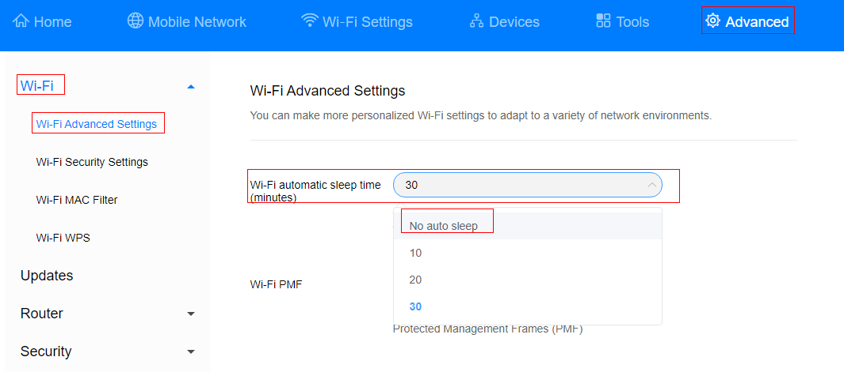Go to **Advanced** > **Wi-Fi** > **Wi-Fi Advanced Settings**, and set **Wi-Fi automatic sleep time** to **No auto sleep** (the default time is 30 minutes).

­­

# View and manage devices connected to the Wi-Fi network

After Wi-Fi access control is enabled, you can set the Mobile WiFi to blocklist mode or trustlist mode as required. In blocklist mode, devices in the blocklist cannot connect to the Mobile WiFi. In trustlist mode, only devices in the trustlist can connect to the Mobile WiFi. Setting the Wi-Fi blocklist and trustlist enhances network security. The Mobile WiFi can restrict user access even if someone knows your Wi-Fi name and password.

Method 1: On the Mobile WiFi screen

Power on the Mobile WiFi and access its home screen.

Swipe up on the home screen to go to **More** > **Device access**. Find the device you want to block, and toggle on the switch next to it.

Method 2: On the web-based management page

Connect your device to the Mobile WiFi. Enter **192.168.8.1** in the browser's address bar, and enter the login password of the web-based management page to log in.

Go to **Advanced** > **Wi-Fi** > **Wi-Fi MAC Filter**. Enable **Wi-Fi MAC Filter**. Set the Mobile WiFi to blocklist mode (blocks the access of devices in the list) or trustlist mode (allows the access of devices in the list) as required.

Set **Filter mode** to **Block** or **Allow**, and click  to add Wi-Fi devices to the Wi-Fi MAC address list. Then click **Save**.

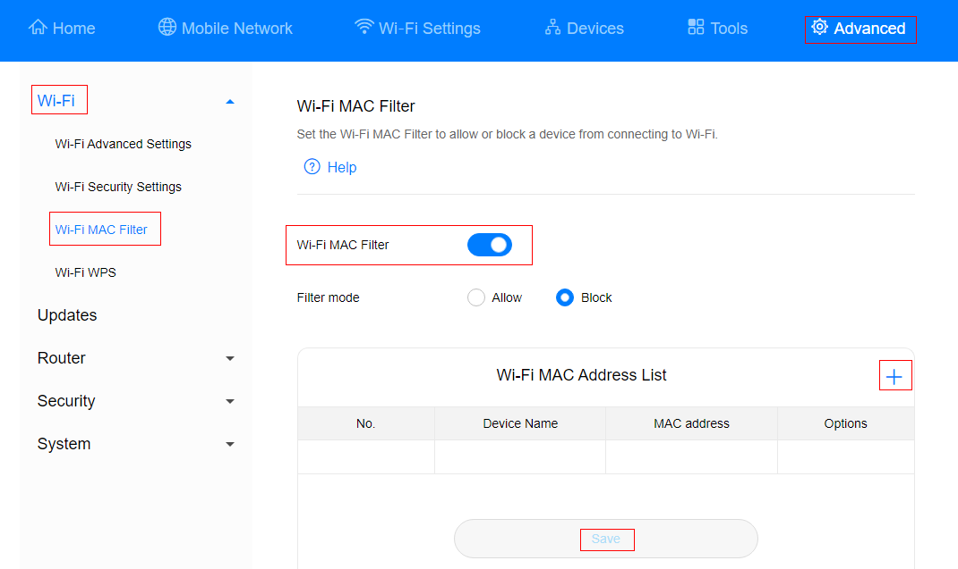



* After the devices are added, you can view them in the Wi-Fi MAC address list.
* If you do not want to use the blocklist or trustlist function, disable **Wi-Fi MAC Filter**.
* MAC address filtering supports a maximum of 32 devices.

# View and manage data traffic

You can view and manage data traffic in either of the following ways.

Method 1: On the Mobile WiFi screen

Power on the Mobile WiFi and swipe left or right to find the screen that displays the used mobile data. You can also swipe up on any home screen and go to **More** > **Manage data** to view your mobile data usage.

On the mobile data management screen, you can select **Clear data** or **Package settings**.

On the **Package settings** screen, open **Data settings** (This button is disabled by default.), you can set the data limit and settlement day as required. If the data limit is reached, a reminder will display on the screen, but you will still be able to access the Internet.

Method 2: On the web-based management page

Connect your device to the Mobile WiFi.

Enter **192.168.8.1** in the browser's address bar, and enter the login password of the web-based management page.

Go to **Tools** > **Statistics** to view and manage data consumption.

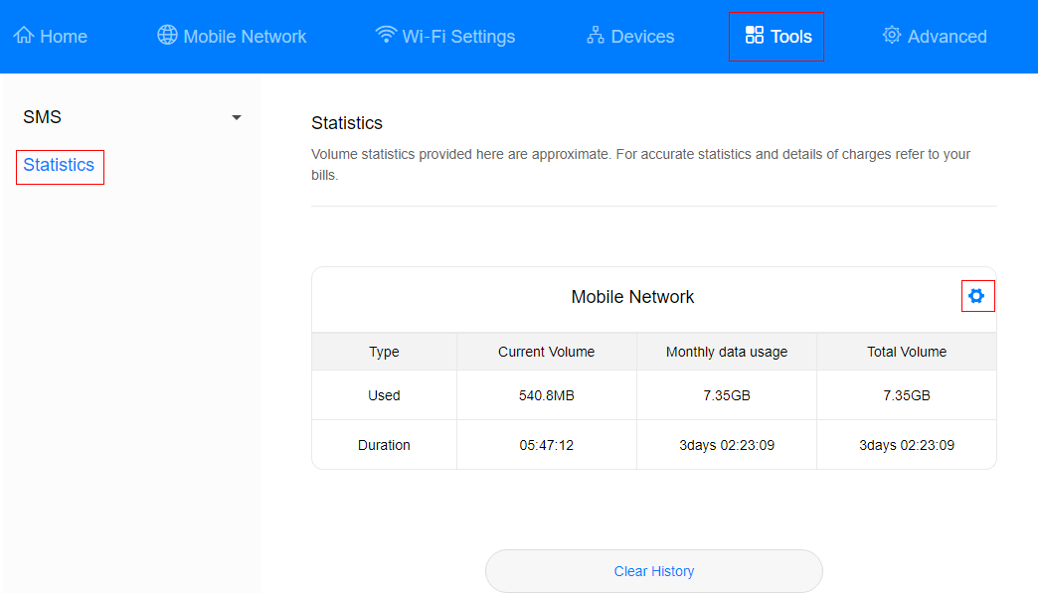Click  to set the mobile data limit.

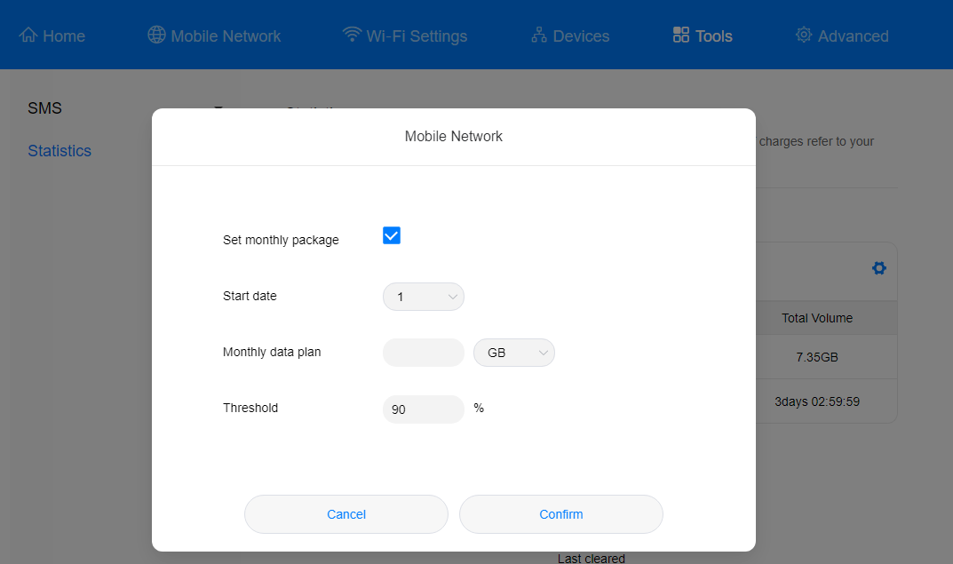

If the data limit is reached, a dialog box will display on the web-based management page, but you will still be able to access the Internet.